Блиц-тур по английскому языку
общешкольной игры по предметным станциям
«Интеллектуальный марафон»
5-10 классы

Автор разработки:
Левенцева Татьяна Александровна, учитель английского языка МОУ «СОШ №23» г. Воркуты

Предлагаю один из вариантов заданий блиц-тура по английскому языку для 5-10 классов, который проводится в рамках общешкольной игры по предметным станциям «Интеллектуальный марафон» в конце учебного года.

Цель: активизировать интерес учащихся к изучению английского языка

Задачи:
- расширение кругозора учащихся;
- развивать умение применять полученные знания;
- развивать логическое мышление, быстроту реакции;
- развитие умения работать в сотрудничестве;
- воспитывать уважительное отношение друг к другу и к другой культуре.

Оборудование: карточки с заданиями, бланк фиксации времени, часы/ таймер/секундомер (на выбор организаторов).

Комментарии
Один из вариантов проведения: тур проводится между командами классов из 3-4 человек по параллелям. Карточки с заданиями раскладываются на парты команд заранее заданием вниз или выдаются в конверте по прибытии команды на станцию. Бланки с заданиями одновременно являются бланком ответов команд. Команды приступают к выполнению заданий по сигналу организатора. Организаторы фиксируют на доске время начала соревнования и время, когда каждая команда сдала заполненный бланк c заданиями. Это время указывается и в маршрутных листах команд. При определении победителя тура учитывается время, затраченное командой на выполнение заданий и количество набранных баллов. Победителем является команда, быстрее всех набравшая наибольшее количество баллов.

MARATHON: English, 5
Team ___________________________

Task 1. Study Morse Code and then decode one of English proverbs (2 points). Give its Russian equivalent (3 points).
Remember: / - between letters, // - between words.
(Total: 5 points)
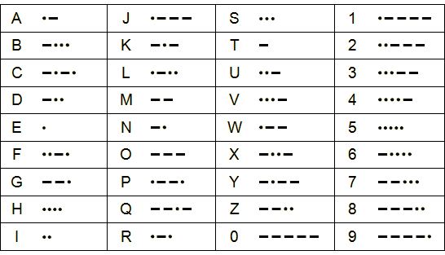

Break the Code

…. - // . / - . - - / . / … // … / . / . // - - / - - - / . - . / . // - / …. / . - // .. - - -

Russian equivalent______________________________________________

Task 2. (5 points) Being in a great hurry your Granny put currant, raspberry and strawberry jam in three jars with labels ‘Raspberry’, ‘Strawberry’ and ‘Strawberry & raspberry’. All the labels turned out to be incorrect. Which jam is in the jar with the label ‘Strawberry’?

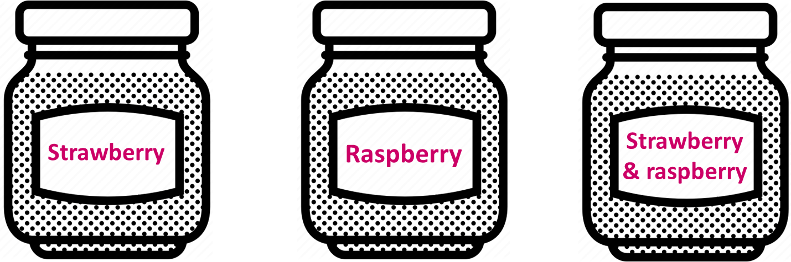

It is ________________________________

MARATHON: English, 6-7
Team ___________________________

Task 1. Study Morse Code and then decode one of English proverbs (2 points). Give its Russian equivalent (3 points).
Remember: / - between letters, // - between words.
(Total: 5 points)

Break the Code

…. - // . / - . - - / . / … // … / . / . // - - / - - - / . - . / . // - / …. / . - // .. - - -

Russian equivalent______________________________________________

Task 2. (5 points) During a recent police investigation, Chief Inspector Holmes was interviewing five neighbours to try and identify who stole Mrs Hudson's pork pies from the patio table. Below is a summary of their statements:

Michael: it wasn't Henry, it was Andrew
Andrew: it wasn't John, it wasn't Henry
John: it was Henry, it wasn't Michael
David: it was John, it was Andrew
Edward: it was David, it wasn't Michael

It was well known that each suspect told exactly one lie. Can you determine who stole the pies?

The terrible crime was committed by ________________________________

MARATHON: English, 8-10
Team ___________________________

Task 1. Study Morse Code and then decode one of English proverbs (2 points). Give its Russian equivalent (3 points).
Remember: / - between letters, // - between words.
(Total: 5 points)

Break the Code

- - - / - . / . // - . /. - / .. /. - ..// -.. / . - . / .. / … - / … //
- - - /.. - / - // . - / - . / - - - / - / …. / . / . - .

Russian equivalent______________________________________________

Task 2. (5 points) After a 5 bikes theft, six suspects were being interviewed. Below is a summary of their statements.
Police know that exactly four of them told one lie each and all of the other statements are true. From this information can you tell who committed the crime?

Ben said: It wasn't Andrew. It wasn't Kevin. It wasn't Frank.
Andrew said: It wasn't Ben. It wasn't James. It wasn't Frank.
James said: It wasn't Andrew. It wasn't Alex. It wasn't Frank.
Kevin said: It wasn't Ben. It wasn't Alex. It wasn't James
Frank said: It wasn't Charles. It wasn't Kevin. It wasn't Alex.
Alex said: It wasn't James. It wasn't Kevin. It wasn't Ben

The terrible crime was committed by ________________________________

MARATHON: English, 5-10
Keys

Task 1
5-7
Task 1. 4 eyes see more than 2. - Одна голова хорошо, а две лучше. (Ум хорошо, а два - лучше)
8-10
Task 1. One nail drives out another. - Клин клином вышибают.

Task 2
5
It is raspberry jam. As all the labels are incorrect, there can’t be neither strawberry nor raspberry jam in the THIRD jar. So, there is Currant jam there and strawberry and raspberry ins in the rest two jars. But, again as the labels are incorrect it means that raspberry jam is in the first jar and strawberry jam is in the second one.

6-7
Task 2. The terrible crime was committed by John.
Looking at Andrew's statements, one of the statements was a lie and the other was the truth. Therefore it must have been either John or Henry.
Looking at David's statements, for the same reason, it was either John or Andrew.
Therefore it must have been John who committed the crime. Double checking this against the other statements confirms this.

8-10
Task 2. The terrible crime was committed by James.
If any other person had committed the crime there would not be exactly 4 lies told, he was the only one who four people said didn't do it (four lies). All other statements are true.

