Конспект урока «Обобщение материала по теме «Настоящее совершённое время»
Я Архипова Алина Викторовна, учитель английского и немецкого языков «МБОУ «СОШ №1» города Сафоново Смоленской области.

Это урок обобщения и систематизации знаний для 8 класса (у меня 27 человек).
Цель:
Отработать с учащимися тему “Present Perfect”.
Задачи:
- Актуализация знаний по теме «Настоящее совершённое время».
- Развитие аналитических способностей.
- Развитие интереса к изучению иностранного языка.
Этот материал будет полезен для учителей английского языка. Урок составлен по учебнику О.В.Афанасьевой, И.В.Михеевой «Новый курс английского языка для российских школ», 8 класс, 4й год обучения.
Я провожу этот урок при изучении темы “present Perfect” в 1й четверти, но можно провести его и при повторении этой темы в любое другое время.
Оборудование:
- Компьютер и проектор или интерактивная доска:
- Доска? Магниты для неё и мел;
- Схема образования Present Perfect (написать или прикрепить к доске магннитами, или высветить на экране):
Длительность: 40 минут.
В своей работе я часто использую джазовые чанты (Jazz chants) и грамматические чанты) Grammar chants) Каролин Грэхем (Carolyn Graham). Это короткие рифмованные строки, которые произносят под музыку под чёткий ритм.
Этап | Учитель | Ученик | Доска | Время
- Организационный момент | - Good morning, everybody! Sit down, please. | - Good morning, Alina Viktorovna! | 20 September  Classwork | 1 минута
- Речевая зарядка | Who is on duty today? Who is absent today? What day of the week is today? What’s the date today? | - I am. All are present. It’s Monday today. It’s the 20th of September. | 20 September  Classwork | 1 минута
- Фонетическая зарядка | Let’s train our tongues. Repeat after me:  Weather, the weather  Victor Warner | Weather, the weather  Victor Warner | [w]  [v] | 2 минуты
- Выведение целей урока. | Look at the blackboard and think what we are going to talk about today. | Present Perfect | Have/has + V3 | 1 минута
- Проверка домашнего задания. | And now let’s check your homework. Present Perfect. Answer my questions, please.  Когда употребляется настоящее совершённое время? Как оно образуется? Каковы его частые спутники? Когда мы используем глагол “has”, а когда “have”? | Настоящее совершённое время употребляется, когда мы говорим о том, что действие произошло в прошлом, а результат мы можем наблюдать в настоящем. I have broken the glass. Образуется оно при помощи вспомогательных глаголов “have” и “has” и третьей формы смыслового глагола. Частые его спутники – слова already, ever, never, just, yet… | Already, ever, never, just, yet | 5 минут
- Закрепление материала. | Now let’s do some exercises. | - Упражнения из учебника  - Opem your textbooks, please. Page 25. Let’s do exercise 7.  - Let’s do exercise 8.  - Let’s have some rest. Grammar chant. Repeat the chant after the speaker, please.  - Turn over the page, please. Page 26.  - Let’s do exercise 9.  - Let’s do exercise 10. Page 27.  - Let’s do exercise 11. Pages 27-28. |  | 25 минут
- Окончание урока. Выставление оценок. | And now open your record books and write down your homework.  You are to write 10 sentences using Present Perfect. | Ok! | Present Perfect: 10 sentences (in your exercise books) | 5 минут
Приложения
Схема образования Present Perfect
Даная схема взята из картинок гугла.
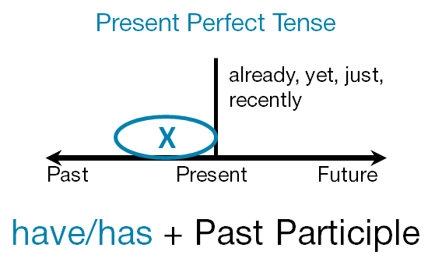
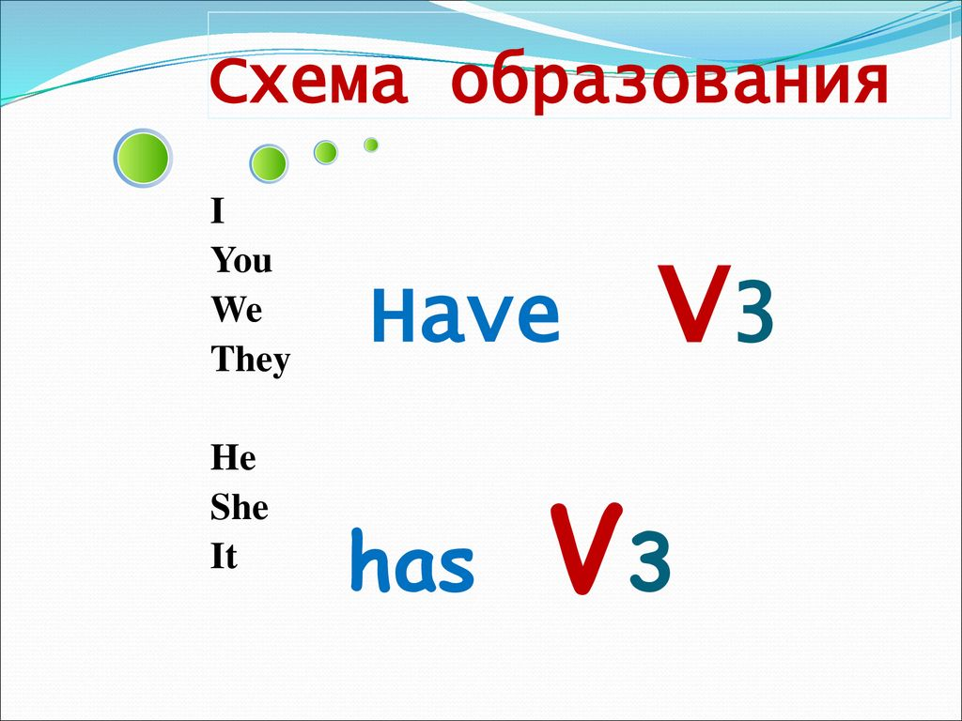
Grammar chant – California roll
Have you ever eaten sushi?
or a California roll?
Have you ever eaten kimchi?
Have you ever been to Seoul?
No, I've never eaten kimchi.
I've never been to Seoul.
And I've never ever ever had
a California roll.
Have you ever been arrested?
Have you ever gone to jail?
Have you ever had a diamond ring
or worn a wedding veil?
No, I've never been arrested.
I've never gone to jail.
I've never had a diamond ring
or worn a wedding veil.
I've never lived in Brooklyn.
I've never lived in Queens.
I've never eaten sushi in a house in New Orleans.
I've never eaten kimchi.
I've never been to Seoul.
And I've never ever ever had a Cаllifornia roll!
No, I've never ever ever had a California roll!
Упражнения из учебника.
Exercise 7, page 25. Make up sentences.
I | have | played football before
We | has | seen all the new films
My friend |  | visited the best museums of the town
Jane |  | cleaned the classroom
They |  | been to the city centre
These people |  | watched the news on TV
You and I |  | asked a lot of questions
 |  | cooked a very good dinner
 |  | finished the work
 |  | decided to have a holiday
 |  | started to write a diary
 |  | listened to some very good songs

Exercise 8, page 25. Say what has happened.
Example: Sam. His shoes are clean. (clean).
Sam has cleaned his shoes.
- James. His car is clean. (wash)
- Kate. Her plants look green and fresh. (water)
- Mum and dad. Their bedroom window is open. (open)
- The children. They are not doing their homework. They are playing in the garden. (finish)
- Mary. She knows what the film is about. (see)
- My friends. They know what the British Museum is like. (visit)
- Emma. Her hands are clean. (wash)
- The Smiths. They know where they’ll spend their weekend.
- Margo. There is a lot of food in her fridge. (be to the shops).
- Jake. His supper is ready. (cook).
Exercise 9, page 26. Today Cinderella is very tired. Can you say why?
Example: She has washed her sisters’ clothes.
В этом упражнении использован скриншот страницы из учебника.

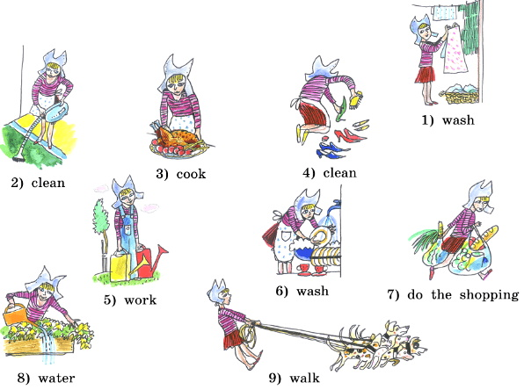

- wash
- clean
- cook
- clean
- work
- wash
- do the shopping
- water
- walk
Exercise 10, page 27. Say what places they have been to (seen, visited) and what places they are going to see.
Example: 1) Ted – New York – Washington, D.C.
Ted has been to New York. He is going to visit Washington, D.C.
- Roy and Alice – France – Germany
Roy and Alice have been to France. They are going to see Germany.
- John – California – Washington
- Billy and Beth – Canada – Mexico
- Harry – the Appalachians – the Rocky Mountains
- The Moles – the Mississippi – the Colorado
- Miss Robertson – Alaska – Hawaii
- Ann – Florida – the Great Plains
- The friends – the Atlantic Ocean – the Pacific Ocean
- Kitty and David – South America – North America
- My cousins – the Pacific Coast – the Atlantic Coast
Exercise 11, page 27.
Complete the sentences.
- Julia (has/have) visited the Grand Canyon.
- Ed and his sister (has/have) travelled about the Atlantic Coast.
- My cousins (has/have) seen “The Big Apple”.
- John (has/have) played five games of tennis.
- The Richardsons (has/have) been to the Great Lakes.
- Alice (has/have) listened to the song “America, the beautiful”. She likes it.
- Boris (has/have) walked in Central Park of New York. Now he knows what it is like.
- Kim’s parents (has/have) been to the Rocky Mountains.
- We (has/have) seen the Appalachians. They are great.
- You (has/have) washed your hands. You may sit down to table.

